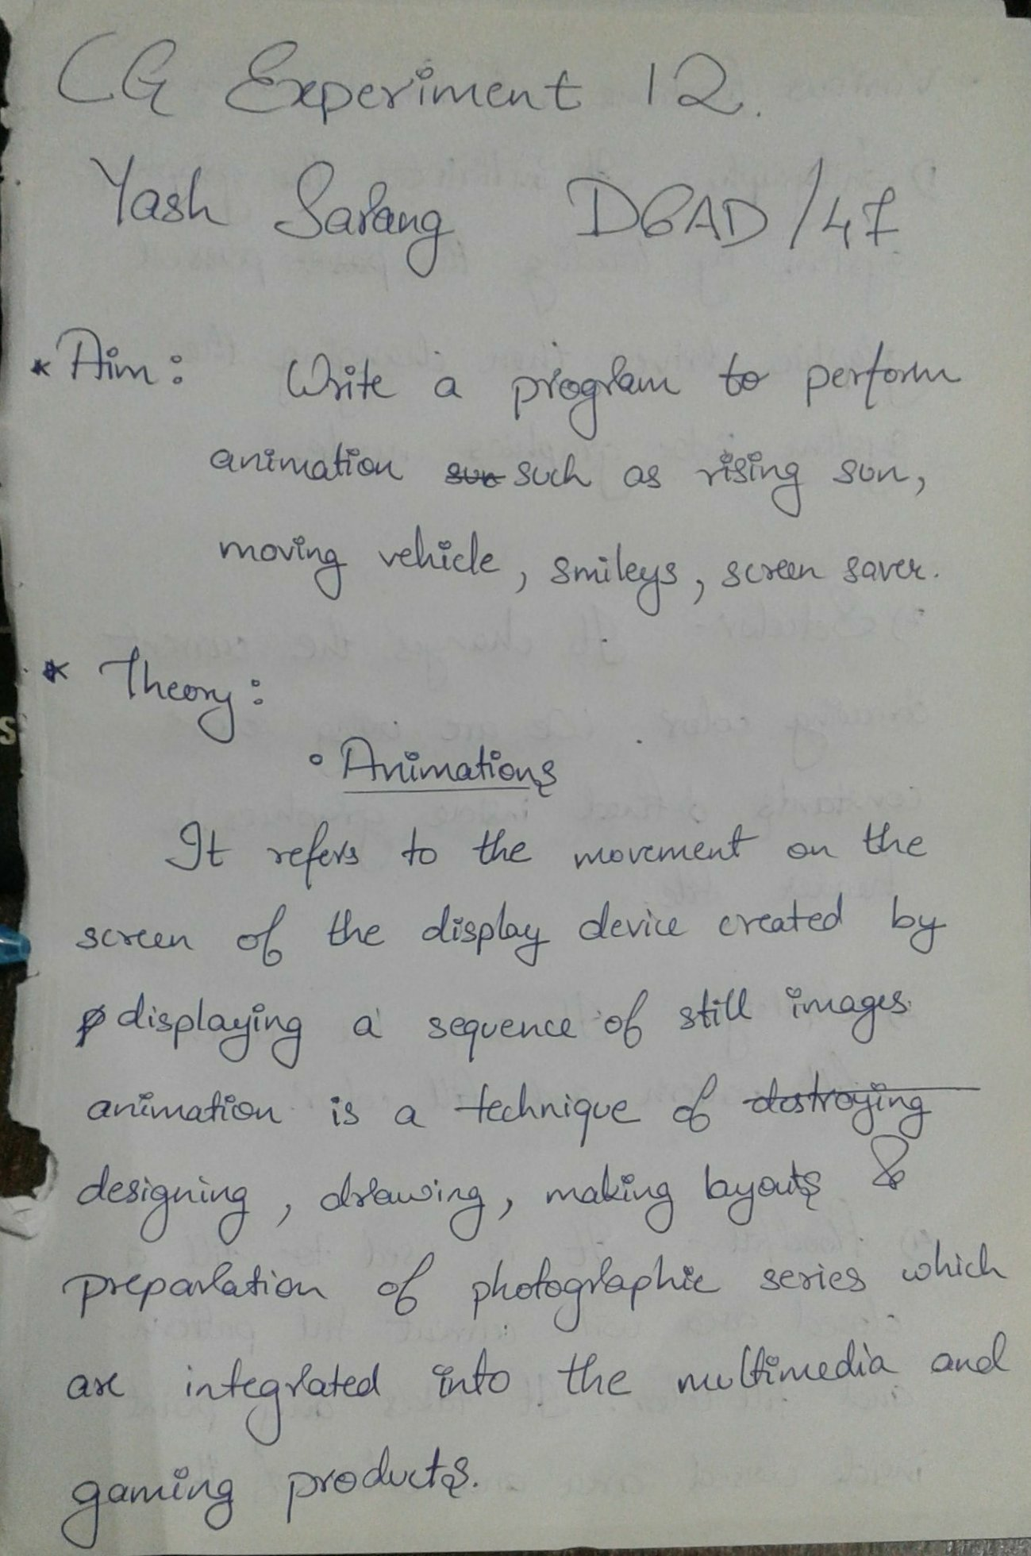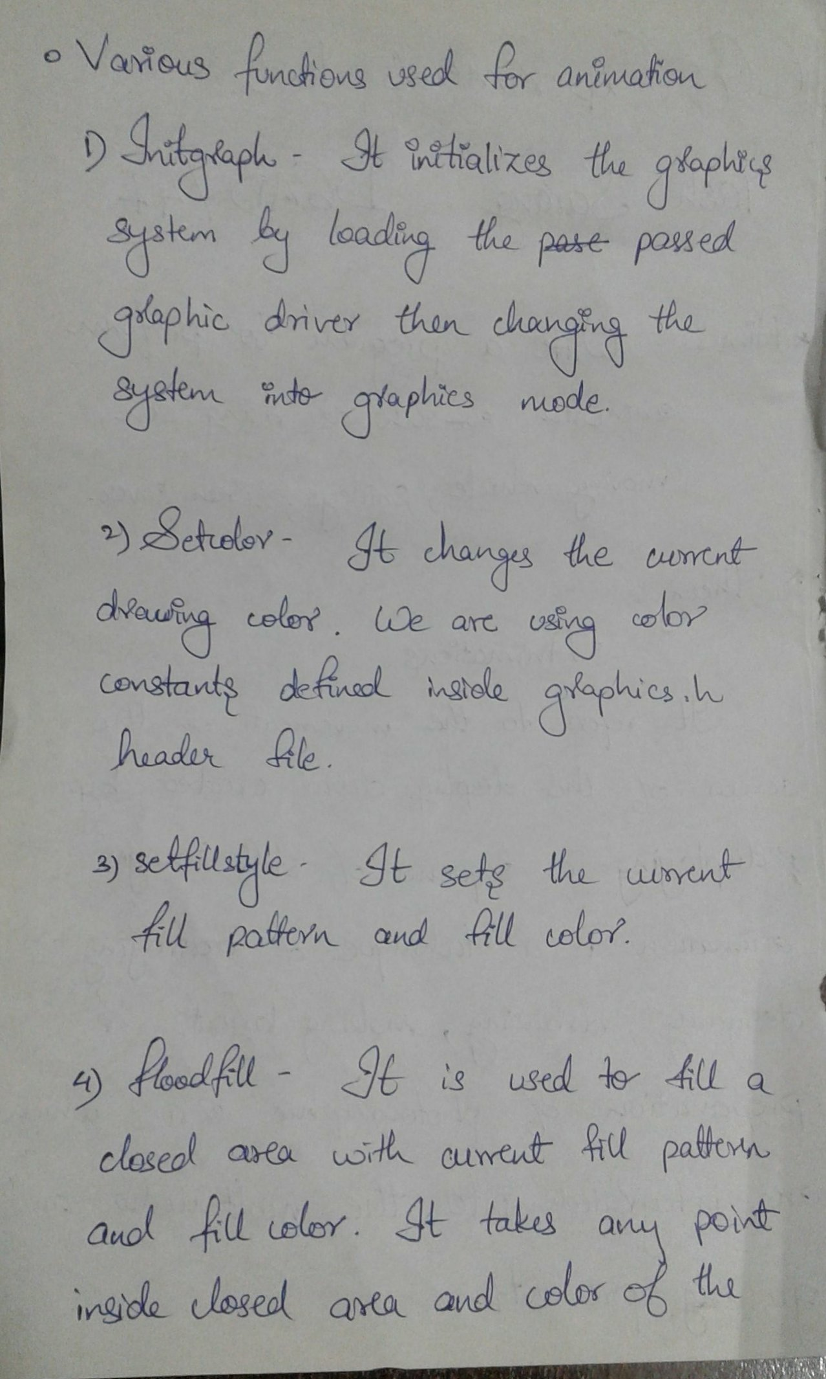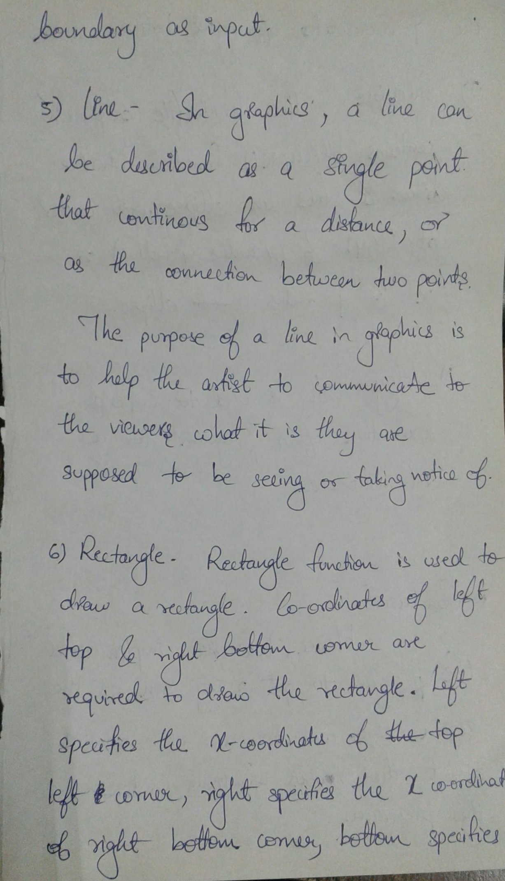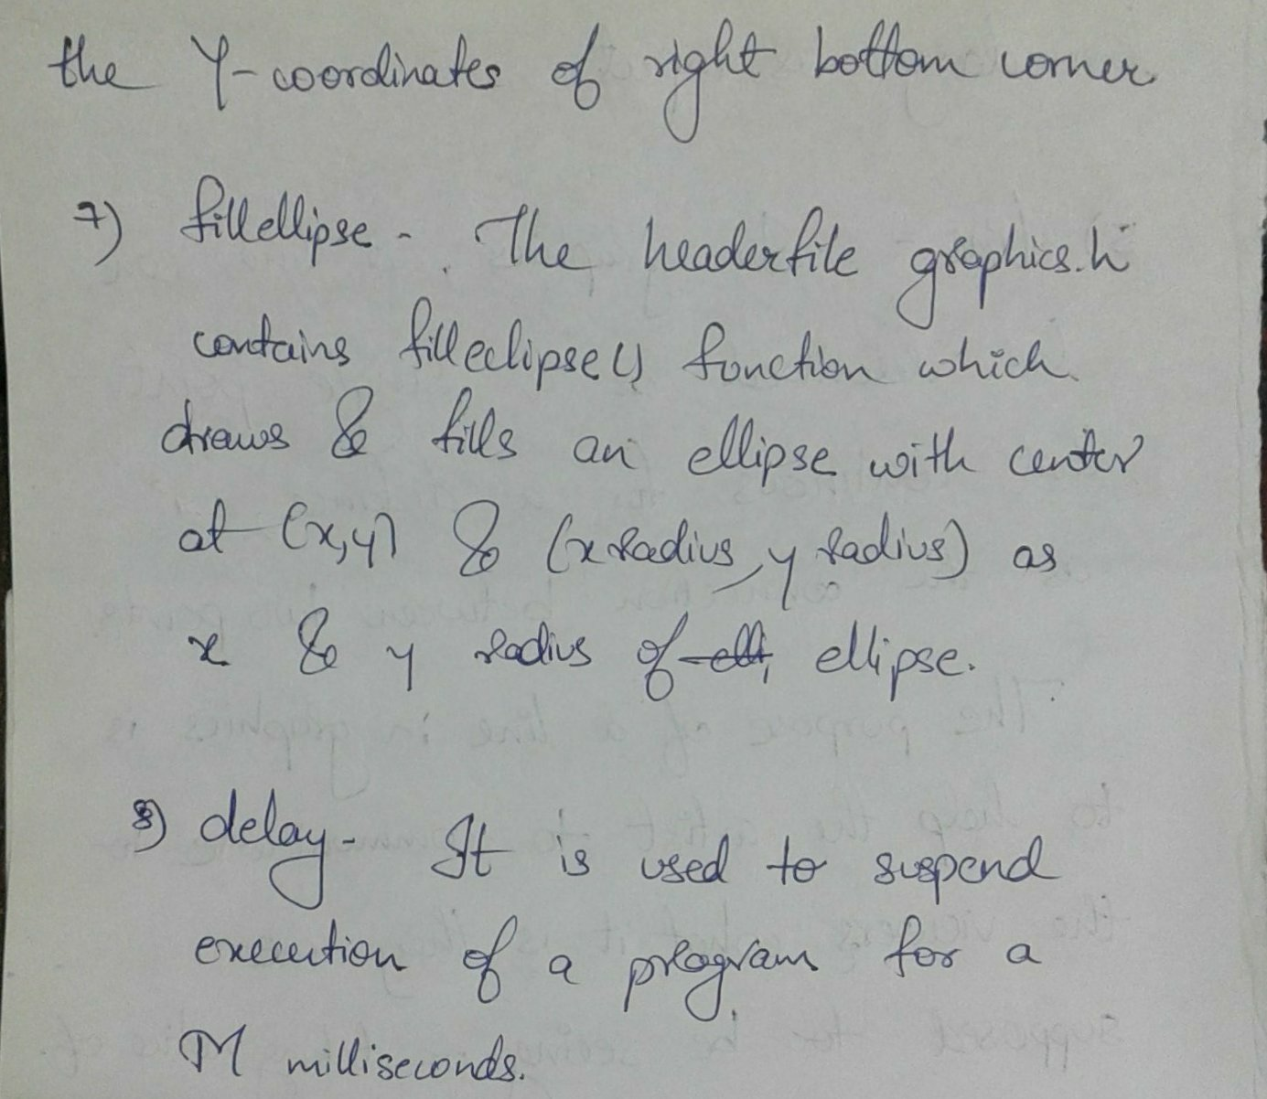  
 --------------------------------------------------------------------------------

CODE:

*#include<graphics.h>*

*#include<conio.h>*

*#include<stdio.h>*

*#include<math.h>*

*#include<dos.h>*

*void main() {*

*int gd = DETECT, gm;*

*int i, j, k, t, q;*

*float x, y;*

*initgraph( & gd, & gm, "C:\\TURBOC3\\BGI");*

*setcolor(3);*

*rectangle(0, 0, getmaxx(), getmaxy());*

*setcolor(2);*

*i = 0;*

*for (t = 0; t < getmaxx(); t += 120) {*

*line(t, 250, t + 60, 170);*

*line(t + 60, 170, t + 120, 250);*

*}*

*line(0, 400, getmaxx(), 350);*

*setfillstyle(11, CYAN);*

*floodfill(2, 420, 2);*

*setfillstyle(4, LIGHTGREEN);*

*floodfill(1, 300, 2);*

*i = 0;*

*while (i != 150) {*

*setcolor(BLACK);*

*setfillstyle(SOLID_FILL, BLACK);*

*fillellipse(k, j, 30, 30);*

*setfillstyle(SOLID_FILL, LIGHTRED);*

*fillellipse(170 + i, 235 - i, 30, 30);*

*j = 235 - i;*

*k = 170 + i;*

*i++;*

*setcolor(2);*

*for (t = 0; t < getmaxx(); t += 120) {*

*line(t, 250, t + 60, 170);*

*line(t + 60, 170, t + 120, 250);*

*}*

*setfillstyle(1, GREEN);*

*floodfill(202, 200, GREEN);*

*delay(25);*

*}*

*for (i = 36; i < 80; i++)*

*for (j = 0; j <= 360; j += 20) {*

*x = 319 + i * cos(((float) j * 3.14) / 180);*

*y = 86 + i * sin(((float) j * 3.14) / 180);*

*putpixel(x, y, LIGHTRED);*

*delay(1);*

*}*

*getch();*

*}*

--------------------------------------------------------------------------------

OUTPUT:





